Name:Vishnu Vijayakumar
Roll No: 53
Batch: S2 RMCA B
Date: 06-06-2022

NETWORKING & SYSTEM ADMINISTRATION LAB

Experiment No: 26 Aim
Wireshark Procedure Commands:
$ sudo apt update
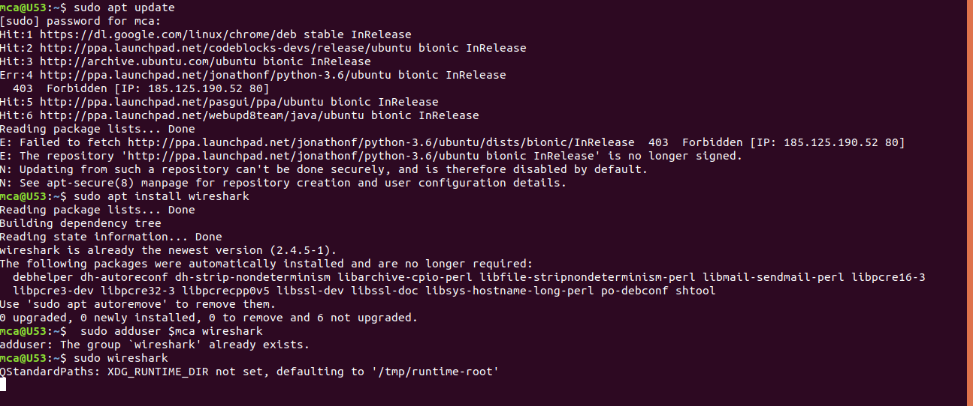

$ sudo apt install wireshark

$ sudo adduser $mca wireshark

$ sudo wireshark
